Survey Design & Implementation

How Much Trust Do Marketers Have in AI Technologies?

Marketing Team

Ali Gowani, Matthew Powers, Mengyuan Han, Joseph Wang, and Ryan Clark

Northwestern University

Introduction to Data Science, Summer 2019

**Survey Design & Implementation**

**How Much Trust Do Marketers Have in AI Technologies?**

**Overview**

In order to have a high-quality survey, we have addressed various areas in our survey and approach to ensure we have minimized bias and reduced sampling errors. Our strategy includes increasing the quality of the data, mitigating missing data and reducing the bias in the approach and design of the survey.

**Survey Design & Methodology**

The objective of this survey is to take the pulse of the marketers’ relationship with artificial intelligence and our hypothesis is that marketers are becoming more confident using AI technologies. Our research uses an online survey to target experienced marketers where we ask for their opinion on AI technology, their current marketing strategy, and future expectations of AI in marketing.

Our sampling frame for this survey are various team members, managers and executives in the marketing function of top companies. We determined the population of our target by looking at Fortune 500 companies and determining the total number of employees and functions within these companies. We were able to gather that there are approximately 25,000,000 employees in these 500 companies (Fortune, 2019). On average, there are 10 functions in each company, such as, Accounting, Communications, Finance, Information Technology, Marketing, Research, Corporate Services, Human Resources, Supply Chain, Manufacturing and Payroll. We extrapolated that our population size therefore is 2,500,000. With a confidence of 95%, margin error of 5% and given our population of 2,500,000, our sample size will be 385.

We have chosen a convenient non-probability sample which is a realistic method to administer a qualitative survey. We selected participants who are available and willing to take part in the interview. We also added strategies of quota sampling that specific our objectives, we attempted to recruit the marketers from various industries with different characteristics. We expect a small range of sampling errors because of the restrictions by adding more observations, but we will control the sampling error by choosing the small variable relationship (Watt & Berg, 2002).

**Research on Questionnaire Design**

According to the book *Design, Evaluation, and Analysis of Questionnaires for Survey Research*, Saris and Gallhofer explain the critical procedure of specification of the concept-by-postulation in concepts-by-intuition to design an effective survey. The concepts-by-intuition are concepts that are more or less immediately perceived by our sensory organs without recourse to a deductively formulated theory (Saris & Gallhofer, 2014). Judgments, sentiments, evaluations, norms, and behaviors are examples of concepts-by-intuition. Concepts-by-postulation receives its meaning from the deductive theory in which it is embedded. Ideally, such concepts would be taken either as primitive or undefined or as defined by postulation strictly in terms of other concepts that were already understood (Saris & Gallhofer, 2014). To measuring the attitudes of interviewees, we use a combination of cognitive, affective, and action tendency components. An operationalization of the concept-by-postulation "attitude toward AI technology" is represented in terms of concepts-by-intuition and questions we designed in Figure 1. The total score for “attitude toward AI technology for marketing” will be obtained as a weighted or unweighted sum of the scores over all the three aspects.

The survey (Exhibit 1) consists of 11 questions. Data collected will inform us of marketers’ confidence levels in AI technologies. The types of questions are multiple choice, checkboxes, dropdown and short answers in free form type. We carefully created prompts that give clear instructions and aid the user in retrieval. We also carefully created answers that limit positivity bias, primacy effect, and recency effect. The survey duration will be approximately 5 minutes. Our final analysis will be translated into a quantitative score that will confirm or deny our hypothesis.

**Areas of Concern**

With the research ethics principle, we chosen opt-in or opt-out approach as sampling techniques. Any of the participants were kindly contracted and freely accept or decline the interview. Collecting high quality data from the response is critical to draw meaningful and accurate conclusion. Poor data may negatively impact the research quality and mislead the decision making for our survey design. Several aspects can affect the overall data credibility including length of questionnaire.

A long questionnaire will result in high data collection costs and a burden on the respondent. If the respondents get distracted, or if the survey is overly complicated, the responses collected might not be valuable. In order to keep respondents’ focused and motivated, our survey is short and interesting to be suitable for all respondents to answer the question easily and effectively without any fatigue (Freeman, 2019). Uncleared perspective of the survey objective will lead to poor understanding of the questionnaires. In order to minimize poor quality data and poor responses in our survey, we took the following steps:

1. We ensured there were no leading questions in our survey by removing language that would sway the responder to a particular response; we used neutral sounding questions to eliminate leading bias. We also carefully designed survey questions which required a rating scale to be on an even number scale; 1 (least) through 4 (most). We purposefully decided not to have a middle response selection to force the respondent to determine favorability instead of picking the neutral value.
2. We reworded questions that were loaded and separated them into multiple questions.
3. We used clear language and did not assume that our respondents would know technical language or jargon. If we used an acronym then we ensure we stated the acronym.
4. Our survey is not mandatory nor misaligned with incentives that increases the likelihood of poor quality responses. The respondents who filled out the survey might be the individuals interested in AI topics utilizing in marketing. In order to increase response rate and reduce the bias of assuming that individuals who answered the survey questions are similar to those not gave responses in the sample. We have to “define the population of interest on the basis of the study’s objectives and its underlying conceptual framework” (Meyer & Wilson, 2009).

**Analysis of Data**

We used the comparative quantitative approach to address the research questions and the hypothesis. Comparative research questions aim to examine the differences between two or more groups on one or more dependent variables ("Types of quantitative research question | Lærd Dissertation", 2019). We hypothesize that marketers are more confident using AI technologies than they were three years ago. The dependent variable for our survey is attitudes towards AI technology and it is made up of multiple measurement items. These measurements are cognition about the usage of AI technology, sentiments of using AI technology, and actions about using AI technology. The total score for “attitude toward AI technology for marketing” will be a weighted sum of the scores over all the three aspects. The groups for research are the same interviewees from three years ago. We will compare the conclusion of this survey to the conclusion from the survey which was conducted in 2016. The analysis of comparative data involves calculation of both descriptive and inferential statistics, as well as the statistical comparison of two or more groups on the quantitative variable (Mertler, 2015).

We will start to dig in and analyze the data after collecting the surveys results. The raw data will be extracted from the Google form and then aggregated and tabulated. The data will be of ordinal, interval, and categorical type. Finally, we summarize the quantitative variable analysis and visualize the survey data.

1. Confirm the validity of all gathered information from respondents:
2. As the scope of survey becomes wide, verify the target population covered sampling frame from which a sample is drawn are all marketers.
3. Look at response rate, our target response rate is 85% of all completed survey out of overall surveys we sent out.
4. Only those surveys were completed during the specific time period are considered as qualified response.
5. The completeness of the survey, all 11 questions have to be answered. Outlier detection from the responses, analyze atypical patterns (Groves et al., 2009).

2. There are three types of survey styles in our survey to be analyzed, analyzing the three main response data types: nominal data, ordinal data and interval data (Peters, 2019). We translated 11 questions into a quantitative scoring scale to come to a quantitative result. Then, we summarize the nominal data with frequencies, which can be translated into percentages to give us a breakdown of the responses.

3. Data analysis through two analysis approaches:

1. Longitudinal trend analysis which can trend the change in marketer’s confidence over time. We expect to see an upward trend in the level of trust in AI (Survey Monkey).
2. Regression analysis which is a correlation analysis between two variables, revenue and confidence level of using AI (Survey Monkey).

**Errors and Bias**

Our survey was designed to minimize total survey error but we do recognize some factors of error. We first recognize a potential measurement error that respondents can falsely answer questions. False answers might be due to embarrassment of lack of technical knowledge, falsely identify their tools as AI when they are not, or they are unaware their tools do use AI. We do not foresee this as a response bias, but this could be response variance.

Secondly, we recognize non-observational errors of coverage error, non-response error, and adjustment error. Our sampling strategy uses email which maximize the effectiveness of our budget without the use of a panel. This will have a bias tilt toward tech-enabled marketers and so our results can suffer from undercoverage. We estimate the non-tech-enabled marketers to be miniscule part of the target population and would have a very small effect on our results. Like all surveys requesting human respondents, this survey is subject to nonresponse bias. Nonresponse rate is a concern as the survey is optional and the method of delivery is email, which we will send to the recipient no more than three times. Given the response rate and the target population, we will be making post-response adjustments to adjust for underrepresented industries. This is subject to adjustment error, or the error that we adjust by improper weightings. Due to the nature of our inquiry there is a danger that our questions may not align perfectly with the construct of our hypothesis. We acknowledge that trust in AI is a quality that is hard to quantify in a survey and therefore we may be subject to validity bias.

**Describe how you will handle missing data**

Missing data can cause many challenges and can even invalidate the overall research survey. Our survey design eliminates the concern of missing data because the survey cannot be submitted until each question is answered. We control to minimize the possibility or receiving missing data. The only way of receiving item missing-data is free from short answer asked about which emerging AI technologies or software do the marketer use. We imputed the missing values by flagging the field of data recorded and replacing with imputed value “Not Applicable.”

**Conclusion**

We hypothesized that marketers are more confident using AI technologies than they were three years ago and we believe that our survey with sufficient sample size will help us accept our hypothesis. We believe with the increase use cases for AI in various marketing roles, functions and tasks, that there will be more trust by marketers to use AI related technologies and accept the recommendations by their AI tools and software.

**Reference**

Types of quantitative research question | Lærd Dissertation. (2019). Retrieved 18 August 2019, from http://dissertation.laerd.com/types-of-quantitative-research-question.php#two

Mertler, C. (2015). Introduction to educational research (2nd ed.). SAGE Publications, Inc.

Freeman, L. (2019, May 08). 22 Tips To Improve Data Quality in Your Research. Retrieved from https://www.positly.com/22-tips-to-improve-data-quality-in-your-research/

Meyer, H., & Wilson, P. (2009). Sampling lesbian, gay, and bisexual populations. Journal Of Counseling Psychology, 56(1), 23-31. doi: 10.1037/a0014587]

How to Analyze Survey Data: Methods & Examples. (n.d.). Retrieved from https://www.surveymonkey.com/mp/how-to-analyze-survey-data/

Peters, C. (2019). How to Design and Analyze a Survey. Retrieved from https://zapier.com/learn/forms-surveys/design-analyze-survey/

Robert, M. G. [et al.]. (2009). Survey methodology. Wiley.

Fortune. (2019, August 20). Fortune 500. Retrieved from https://fortune.com/fortune500/search/

Gowani, A., Powers, M., Han, M., Wang, J., & Clark, R. (2019, August 7). Survey: Marketers' Trust in AI. Retrieved from https://forms.gle/kBdEL45MnSjumLob8

**Figure 1**

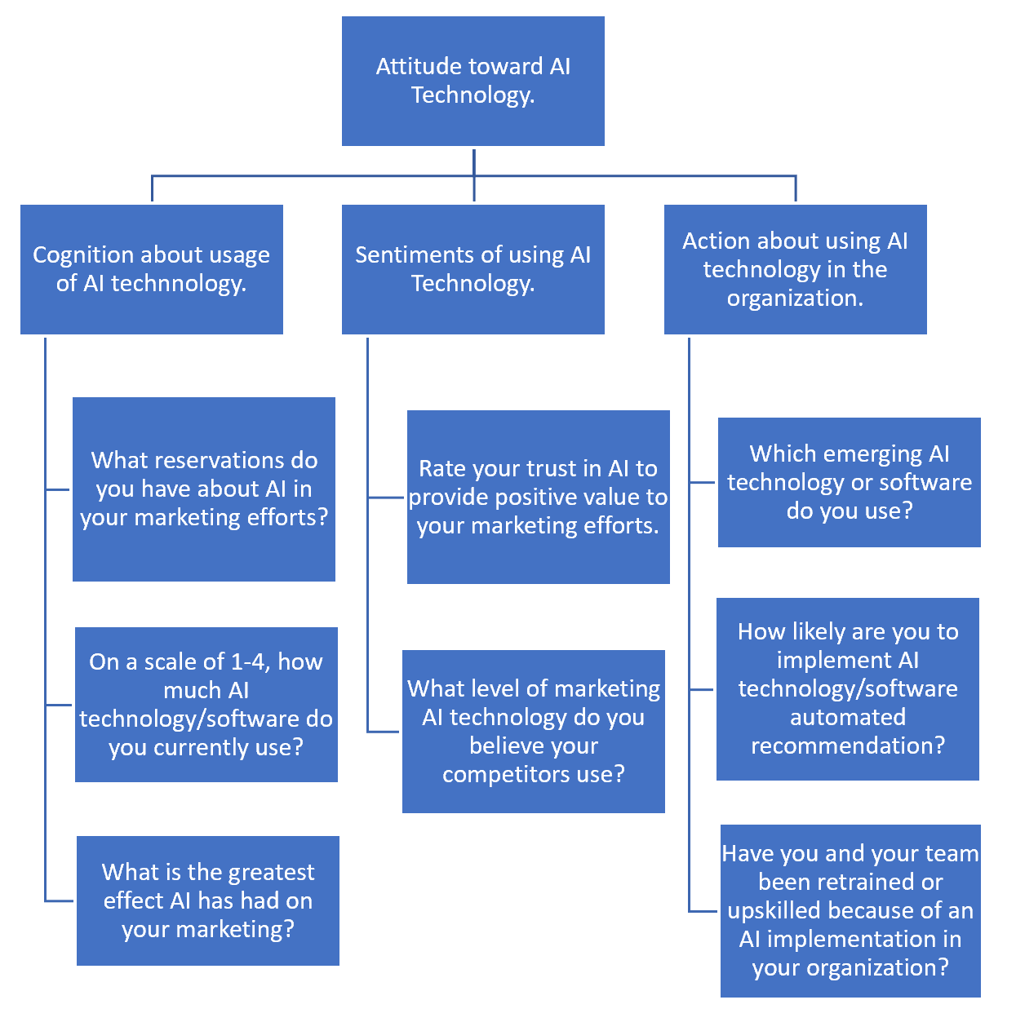

**Exhibit 1**

